**APPENDIX A**

Screen shoot of Each Interface of the system, with a caption explanation of the function of the interface.

**Home page**

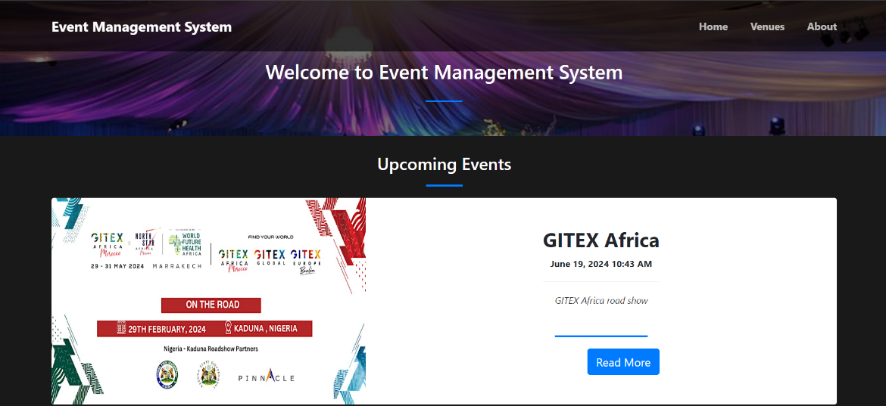

**Dashboard**

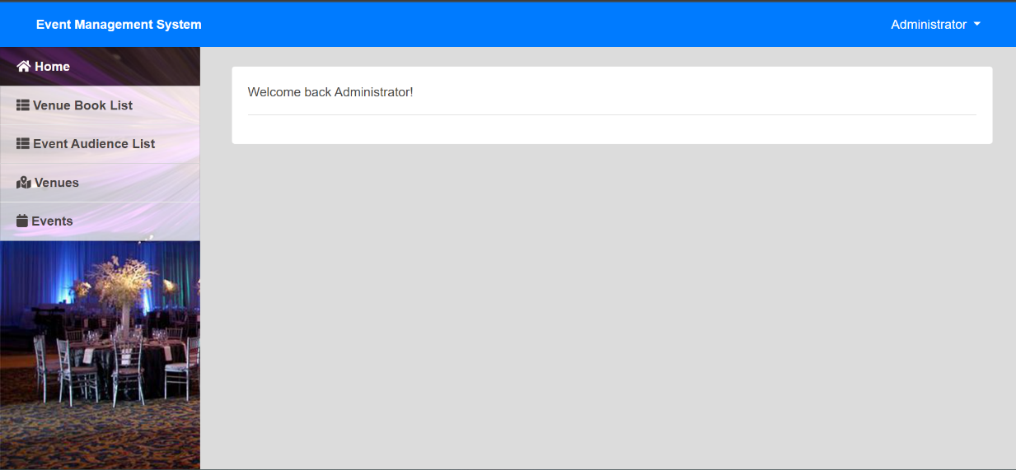

**Booking List**

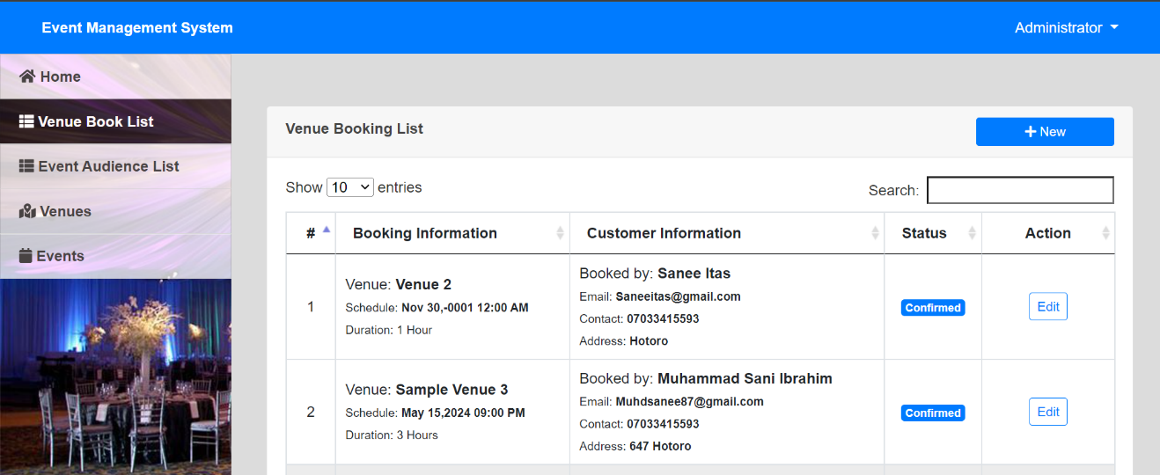

**Audience list**

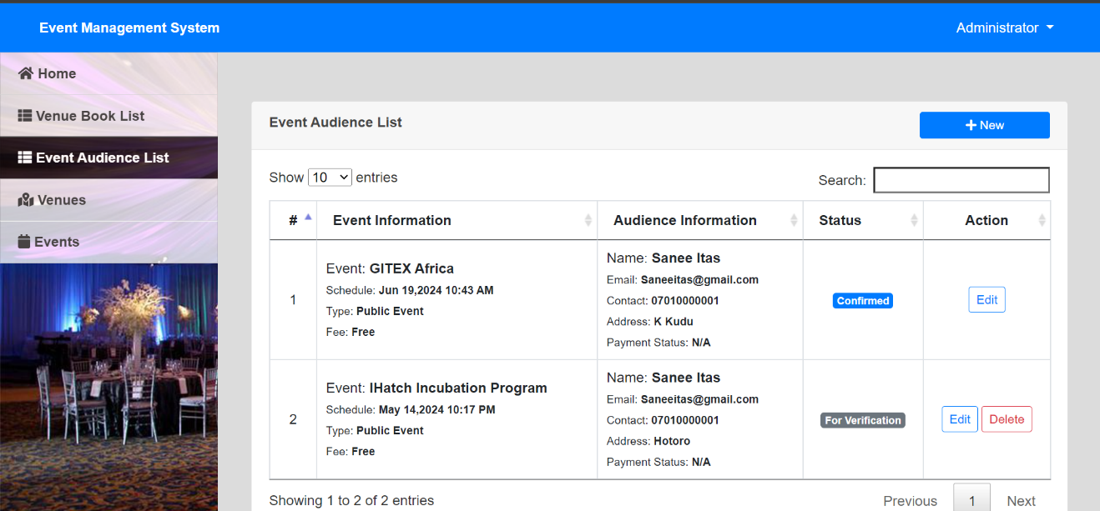

**Venue list**

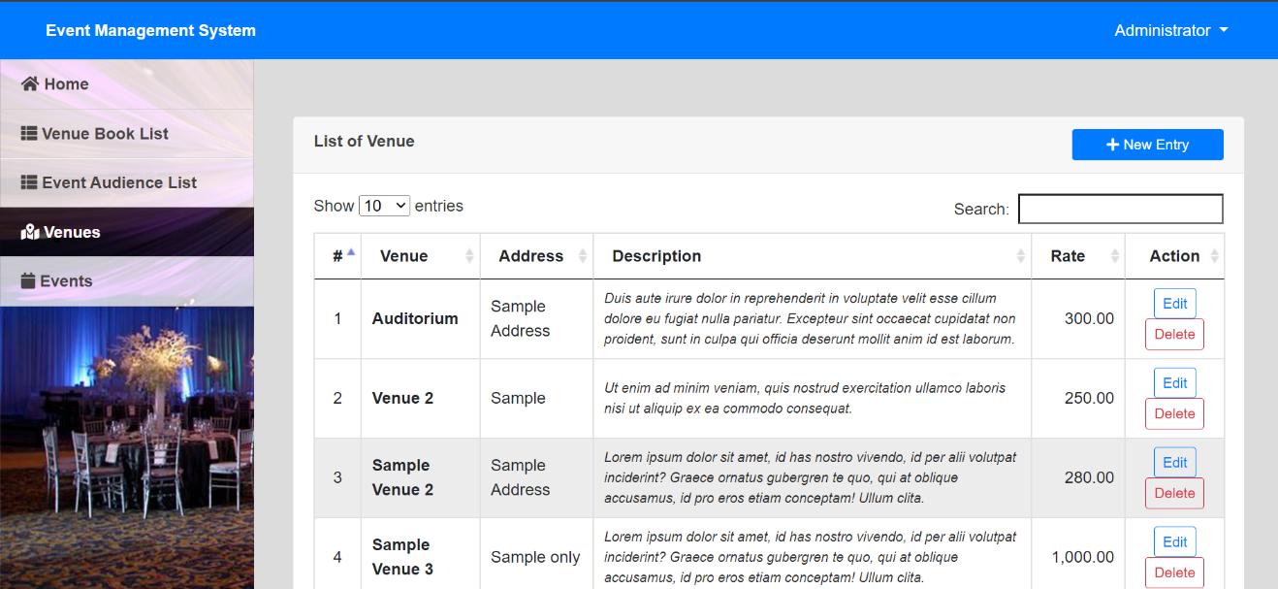

**List of event**

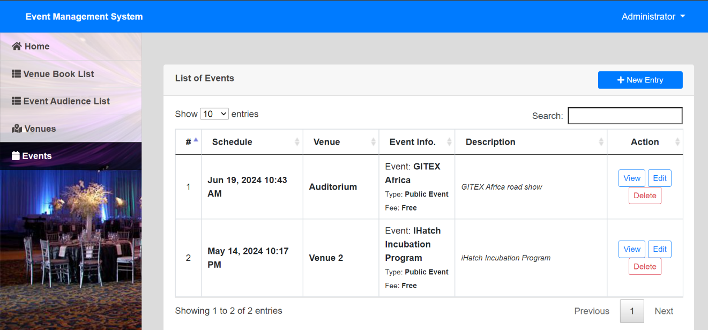

**APPENDIX B**

GitHub repository of the system:

https://github.com/aminatu/event-system.git